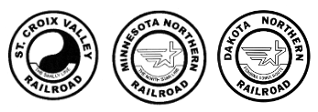
Motor Vehicle Record
Disclosure and Release Form

In connection with my ongoing employment or my application for employment, should I have or secure a position with the Minnesota Northern Railroad, I understand a motor vehicle record, which contains public record information, may be requested. I further understand that such report(s) will contain personal information and public record information concerning my driving record from federal, state, and other agencies that maintain such records, as well as independent services that provide the driving record information.

I authorize, without reservation, any party or agency contacted to furnish the above-mentioned information to Jason Bierwerth, Manager of Operations, with the Minnesota Northern Railroad.

I hereby authorize the procurement of my motor vehicle report. If hired, this authorization shall remain on file and shall serve as ongoing authorization for Minnesota Northern Railroad to procure such reports at any time during employment.

Full Name: ____________________________________________
Driver’s License Number: ______________________________
State of Issuance: ________________
Date of Birth: ____________________
Signature: ____________________________________________
Date: ___________________________

